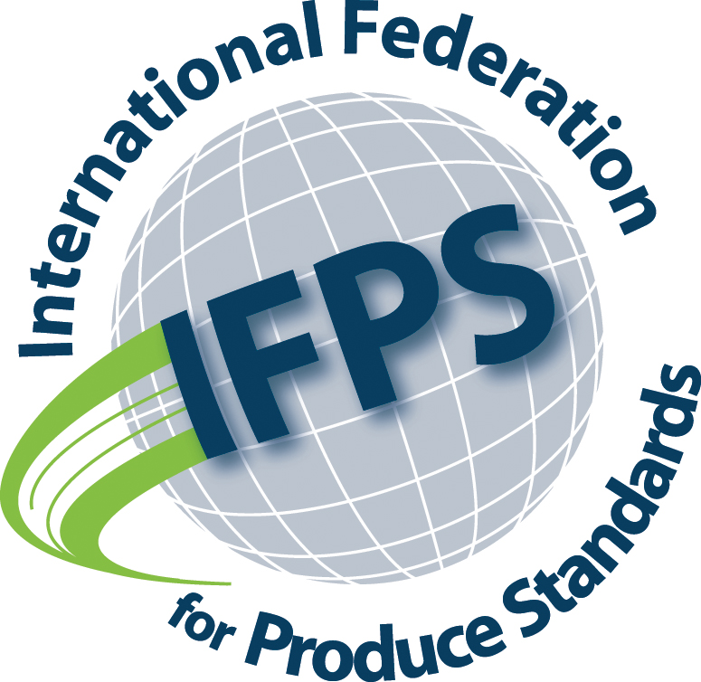

Press Release

The International Federation for Produce Standards (IFPS) has announced today that it is holding its inaugural virtual global sustainability symposium on 10 November, 11am to 2:30pm Eastern Standard Time (EST) – 3pm to 6.30pm Greenwich Mean Time.
IFPS is the voice of fresh produce industry associations from Canada, the USA, Chile, New Zealand, Norway, the United Kingdom, and the Netherlands. Its primary areas of interest are structure, management, and the implications of produce identification standards, food safety standards, and data management standards, on the global fresh produce trade.
In announcing the Sustainability Symposium, IFPS Chair Rebecca Lee (Fruit and Vegetable Growers of Canada) confirmed that the IFPS Board is increasingly becoming concerned about the impact sustainability related initiatives, legislation, regulations, and retailer-initiated requirements are beginning to have on global fresh produce value chains.
“IFPS committed to the United Nations Sustainability Goals in 2017 and supports any initiative that leads, ultimately, to a more sustainable planet. From a fresh produce perspective, however, we need to ensure that sustainability standards developed at different points in the produce value chain are not in contradiction with each other; are not creating unintended roadblocks to domestic and international trade; and are implemented and managed in the most cost-effective way to ensure that value chain participants from growers to retailers are able to effectively adopt and integrate sustainability standards into their businesses.”
Lee described the objective of the 10 November symposium as, “an attempt to reach a common understanding of what sustainability actually means within the global fresh produce industry, and where our emphasis as an industry, going forward, should be placed. Everyone has an opinion on what sustainability means, and those opinions are not necessarily expressed by people with knowledge of how the fresh produce industry works. It is, therefore, time for us to make sure that we are heard better in the sustainability space and that has to start by developing a common position.”
IFPS has developed a discussion paper on Sustainability as a Global Industry Goal, which will form the basis for the symposium. Industry members registering for the symposium will receive a copy of the paper prior to 10 November, in order to prepare for symposium discussions.
Registration for the event can be made here:
https://cpmaacdfl.wufoo.com/forms/ifps-sustainability-symposium/

Requests for further information to:
Rebecca Lee, PhD.
Chair
International Federation for Produce Standards
plu@ifpsglobal.com

